PART-I
User Creation:
STEP 1:
First Login to the URL (http://tathyasathi.bangla.gov.in/configure/login.do) with the credentials as required. 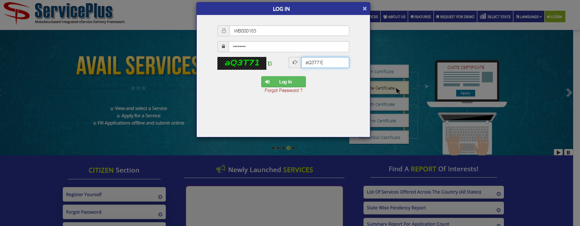

STEP 2:
Now fill in the form with the details.
This would lead to the activation link which would be received in the email given so it would be corrected and activated. Be carefully in fill the information in this window. Full name should be like Gram Panchayat – BHAGIRATHPUR
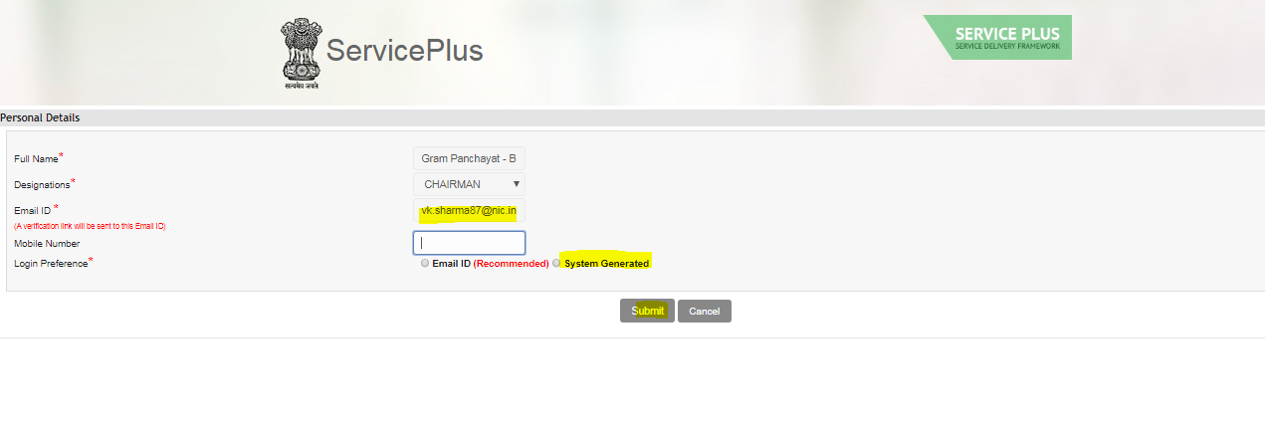

STEP 3:
A verification link is sent on your Email ID given by you e.g.: vkxxxxx@nxxx.in. Please confirm your Email ID by clicking on the link and Reset Password.
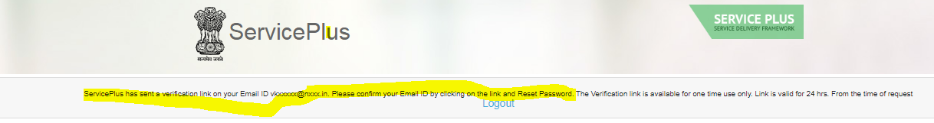
STEP 4:
Open your email and click on the activation link and reset the password.
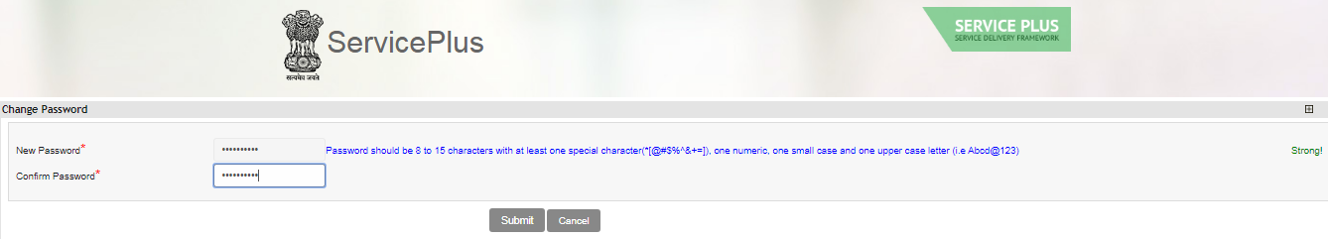
Now the request have been sent to your Admin for approval.

PART -II
Step to create computer operator user:
STEP 1:
Login as a panchayat department Admin in service plus. Create one user from user management option.
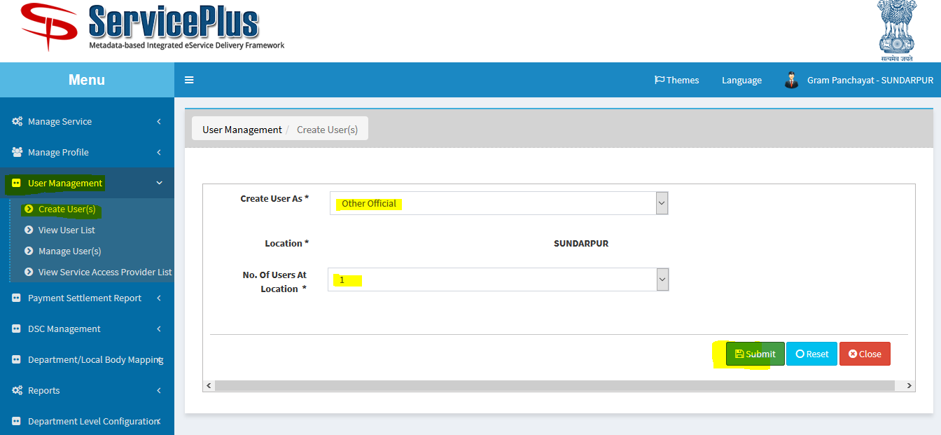

STEP 2:
A notification would notify you that the no. of user has been created.
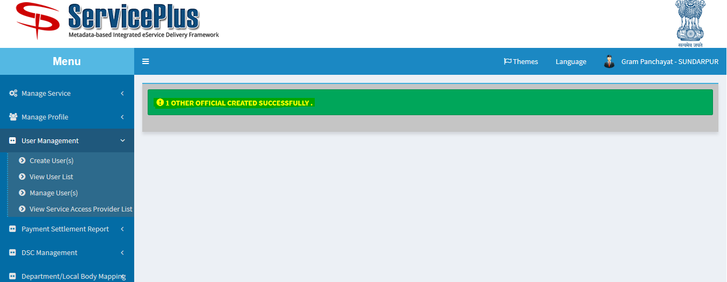
STEP 3:
The user created details are sent to the mail as shown.
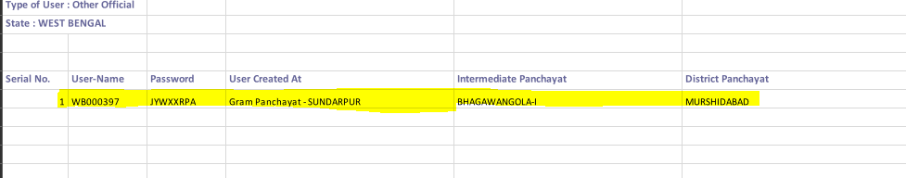
STEP 4:
Re login by the new credentials provided.
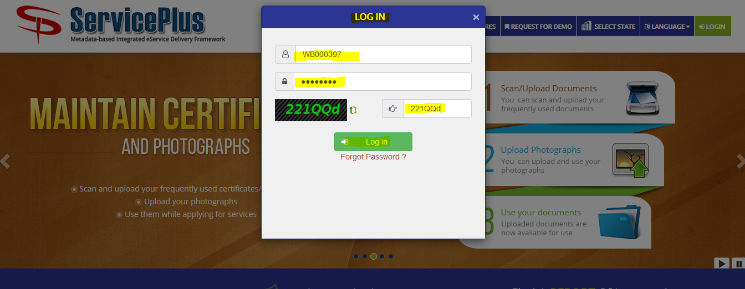

STEP 5:
Login into service plus with the credential provided in the email. Fill in the form with details .Activation link is received in the email so it should be corrected and activated. Be careful in filling up the information in this window. Full name should be like “Gram Panchayat – SUNDARPUR-Computer Operator”. Designation should be data entry operator
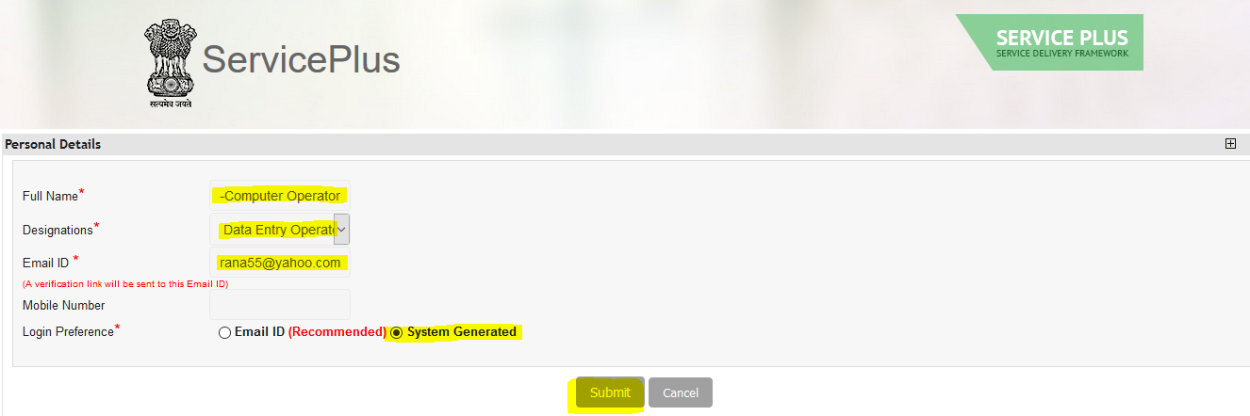
STEP 6:
Service Plus has sent a verification link on your Email ID vkxxxxx@nxxx.in. Please confirm your Email ID by clicking on the link and Reset Password
Open the mail and click on the link and reset the password
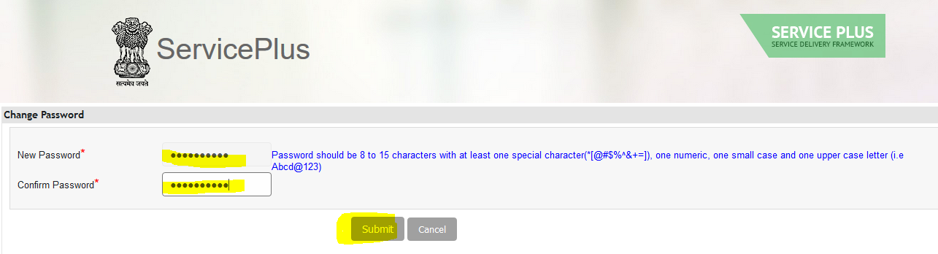

STEP 7:
Login as a panchayat department Admin and go to “User Management” and “Manage Users” and approve the user
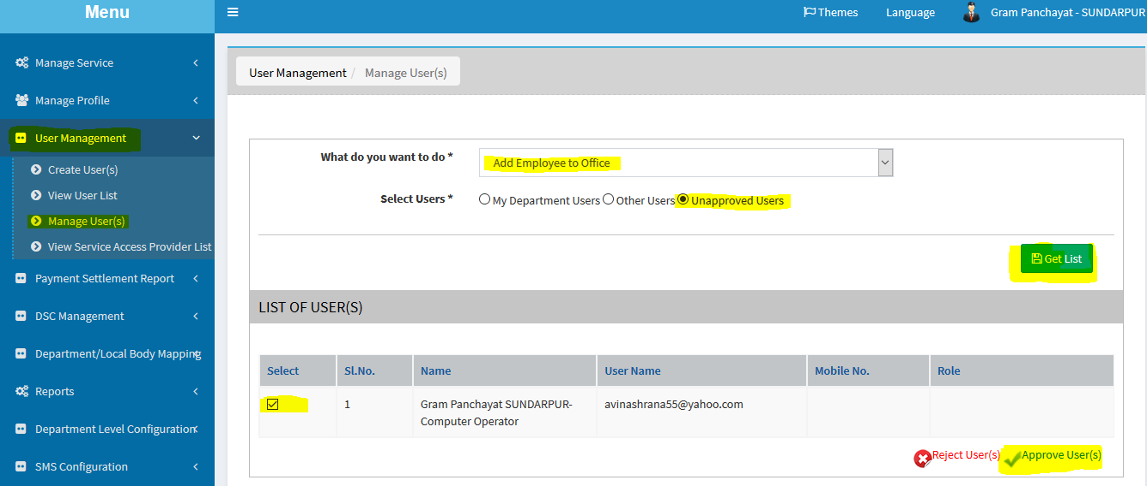
STEP 8:
Now check the “Date Entry Operator” check box and submit to approve.
